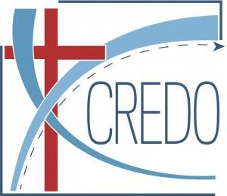
Economics and Catholic Social Thought Conference
Sponsored by CREDO, the Lumen Christi Institute, & Pontificia Universidad Católica de Chile (PUC) July 27th – August 1st
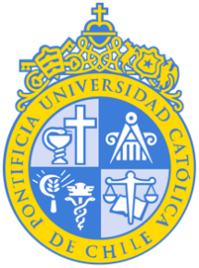
Sunday, July 27th
Check into hotel upon arrival
19:00 pm Opening Reception, PUC Terrace Nueva Las Condes Campus (Rosario Norte 407, Las Condes, floor-1).

Monday, July 28th
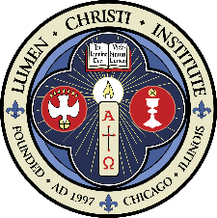
All sessions will take place in room AE101, Facultad Economía y Administración, San Joaquín campus.
9:00 am Session 1. Theology of CST and Economics, Mary Hirschfeld
10:15 am Coffee Break (study room n°2, second floor)
10:30 am Session 2. The Philosophical Foundations of Catholic
Social Teaching, Cristián Hodge
12:00 pm Lunch, PUC Copper SJ
1:40 pm Mass - PUC, Chapel
2:30 pm Session 3. Economics and the Technocratic Paradigm, Mary Hirschfeld
7:00 pm Dinner, Location Hampton by Hilton Restaurant 13th floor

Tuesday, July 29th
All sessions will take place in room AE101, Facultad Economía y Administración, San Joaquín campus.
08:30 am Optional group excursion: Santiago Cathedral
12:00 pm Mass, Location Santiago Cathedral
1:30 pm Lunch, Location PUC Copper SJ.
14:30 pm Session 4. What the encyclicals say about economics and social science, Andy Yuengert
15:45 pm Coffee Break (study room n°2, second floor)
16:00 pm Session 5. Creation and Order in Economies, Kirk Doran
Dinner on your own

Wednesday, July 30th
All sessions will take place in room AE101, Facultad Economía y Administración, San Joaquín campus.
9:00 am Session 6. Property, Profit, Markets, and Gratuitousness, Andy Yuengert
10:15 am Coffee Break (study room n°2, second floor)
10:30 am Session 7. Labor, Kirk Doran
12:00 pm Lunch, PUC Copper SJ.
1:40 pm Mass- PUC, Chapel
2:30 pm Session 8. A look at Sustainability in CST, Francisco Gallego and Román Guridi
3:30 pm Coffee Break (study room n°2, second floor)
3:45 pm Session 9. Integral Human Development and Economic Development, Joe Kaboski.
7:30 pm Dinner Location Olivia Restaurant (Ibis Restaurant O’Connell 165, floor -1)

Thursday, July 31st
9:00 am Optional group excursion, Saint Therese Sanctuary + Valparaiso.
7:00 pm Dinner in Valparaiso, Location Nogaro Restaurant.

Friday, August 1st
9:00 am Mass, Location PUC Casa Central Campus (presided over by Cardinal Fernando Chomalí G.)
10:00 am Session 10. Lessons from My Social Enterprises in Concepción, Conversation with Cardinal Fernando Chomalí G. Salón de Honor, Casa Central Campus.
11:25 am Coffee Break
11:40 am Session 11. Values for Transformation: Academia, the Individual, and Business through the Lens of Catholic Social Thought
A conversation with Joe Kaboski, José Miguel Sanchez (Dean at Católica) and Richard Von Appen, representative of USEC (Social Union of Christian Entrepreneurs, Executives, and Businesspeople Chile). Father Jorge Merino, Main Chaplain at UC Chile will moderate. Salón de Honor, Casa Central Campus.
13:00 pm Lunch, PUC Copper Casa Central
2:30 pm Session 12. Closing Session. Impact of Catholic social thought on teaching, research, and work in economics, Group discussion. Comedor de Rectoría, Casa Central Campus.
Dinner on your own
Saturday, August 2nd Check out of hotel and depart

